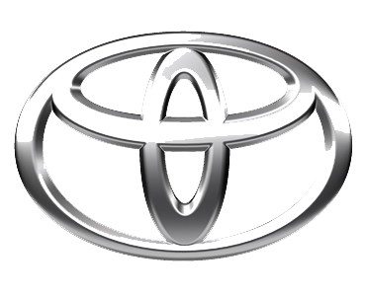
undefined
TOYOTA MOTOR CORPORATION
I. TOYOTA-CHO TOYOTA. AICHI, 471—8571(HEAD OFFICE)
or 471 8572 (Research 5 Development Group) THAILAND
TEL: +81-565-28-212

GSO Conformity Certificate CCR No. 432056
Motor Vehicles
Manufacturer: FORD
Country of Origin: THAILAND, Country of Production: THAILAND
To: GCC Standardization Organization (GSO)
We hereby certify that the vehicles manufactured by FORD
* Type: JHFHTFJ
* VlN number: MPBAMFE1*S*******
* Model Year: 2025 * Produced in and after: Month 07 Year 2025
* Category: Truck
Will satisfy the G50 Technical Regulations Nos: 34:20o7, 3s:2007, 36:2005, 37:2012, 38:200s, 392005, 40:2011,42:2015, 48:1984, 51:20o7, 52:2007, 53.2007, 9611988. 9721988, 9811988, 9921988,13522007, 13622007. 29021994. 4119:1994,42o:1994,421:2005,422:200s.1040:20001041:2000,1042:2000,1053:2000,1503:2010,1598:2002,1624:2002,1677:2003,1708:2o0s,1780:2010,1781:2006,1782:2008,1783:2006,1784:2o0e.Gsolso1585:2008,GSO lSO 3537:2008, GSO 150 3538:1997, G50 ECE13H:2012,GSO ECE13H-1:2012,GSO ECE13H-2:2012,GSO ECE 13H-3:2012, GSO ECE13H-4:20l2, GSO ECE13H-S:2012,GSO ECE 13H-6:2012 and the standards in the country of origin accepted by GSO in the case that no GSO technical regulations and standards are available.
All the essential technical data are as follows:
1. Weights
a. Maximum Vehicle Weight: 3080 kg b. Curb: 2436 kg
c. Maximum Axle Weight: Front: 1350 kg Rear: 1500 kg
2. Dimensions
a. Length: 5356 mm b. Width: 2028 mm
c. Height: 1928 mm d. Wheelbase (Fl R1) 3270 mm e. Track: Front: 1710 mm Rear: 1710 mm
3. Type of chassis and body: Body-on-frame
4. Number of Passengers: 5(Including the Driver)
5.Engine: Petrol a. Cylinders: 6 b. Displacement: 2956cc c. Air intake: Turbo
d. Net Engine Power: 405 kW at 5500 rpm Pollutant Limit comply with Euro 6.
6. Transmission: Automatic

7. Brakes a. Service Brakes: Hydraulic b. Emergency Brakes: Combined with the service brake
8. Fuel Economy a. Motor Vehicle Class: Light Truck b. FE (CAFE) Combined: 7.2.7 km/L - Excellent
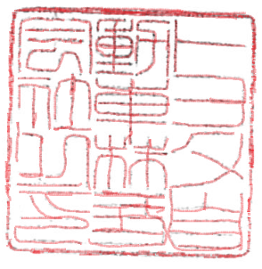
9. Any other information or local standards to be compiled: Also comply with the National regulations for member countries mentioned in the Annex of the list of Technical Regulations for MV 2025 MY-D5, when exporting to those countries. for member countries mentioned in the Annex of the list of Technical Regulations for MV 2025MY-D3, when exporting to those countries. for member countries mentioned in the Annex of the list of Technical Regulations for MV 2025 MY-D3, when exporting to those countries.
Keiko Yanagi
23 APR 20262025
general Manager Regulation &Certiﬁcation Division

